**DEVOPS TEST**

**Q1 Scenario:**

1. In azure devops when we are creating a build pipeline we can add some triggers to that pipeline like mentioning the specific git branch. So when ever the source code is checked in automatically the new build is created.

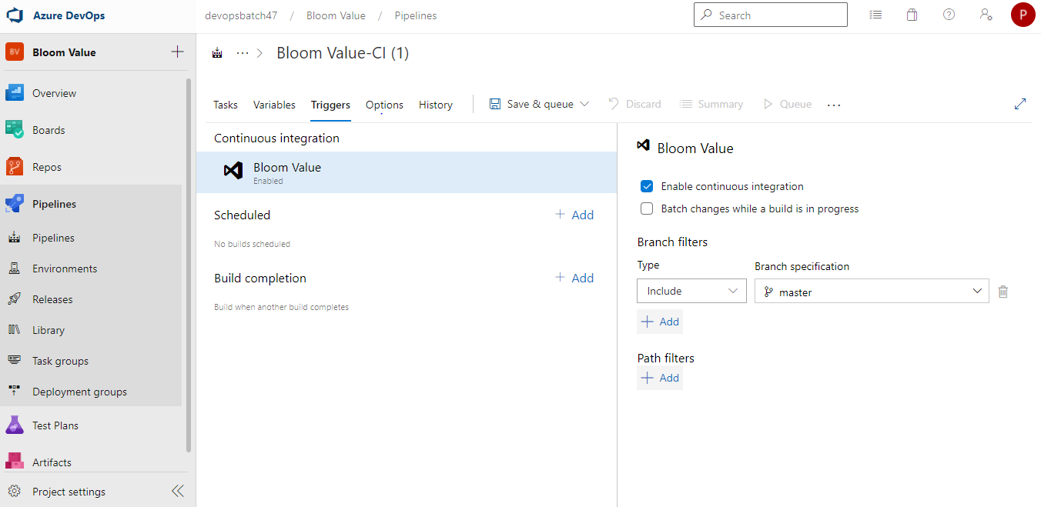

1. In the same pipeline there is a option under triggers tab called build completion. So, when we trigger a pipeline and that pipeline build completes then another pipeline starts running. As mentioned, if any build pipeline fails due to test case failure then other pipelines also not triggered.
2. 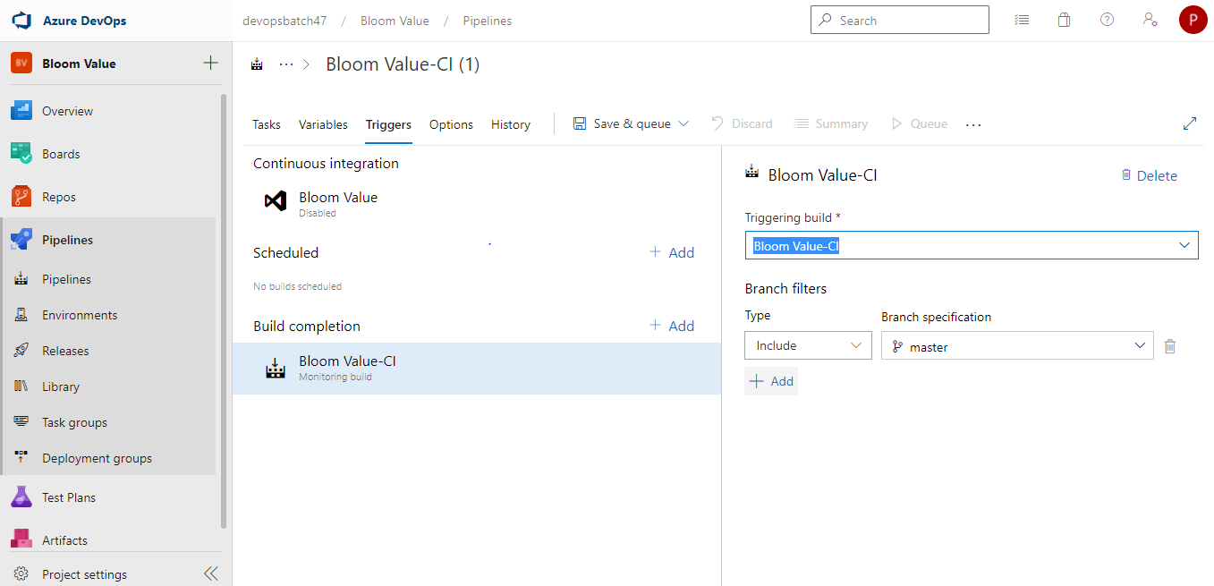
3. In the release pipeline once we select the artifact and for each environment we add different stages. But in the dev environment we select the continuous deployment then the artifact created in the build pipeline is deployed to the dev environment.
4. As mentioned in the above point we can select the continuous deployment. So, the package can be deployed to the other environments in the release pipeline. Refer to below screenshot of how we can enable the continuous deployment once we add the artifacts on top, we can see thunder button which will be used to open the pop up as shown in screenshot.

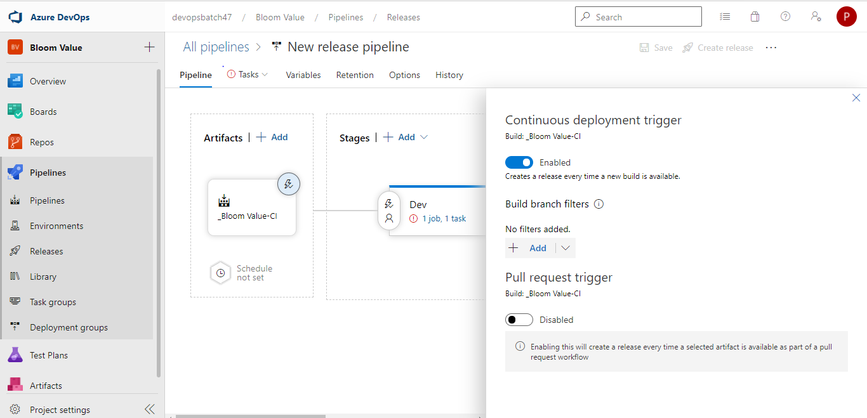

1. We can add the approvals between each environment before deploying the package. Please refer below screenshot.

